Buildings structure:
- A main part of the buildings heating and cooling losses is through the roof, walls, windows and floor. Insulation of these parts of the building is the most effective and most important way to save energy.
- Preventing of air leakage is most simple and most affordable way to avoid excessive consumption of energy, especially in the cold months of the year. For example, heat loss from the seams and gaps between the doors and aluminum windows that rarely are properly installed in our country.
- Using double-glazed windows, particularly windows with low radiation, is an important contribution to energy savings and especially in buildings with little windows, it is a cost effective way.
- Wooden windows, especially in cold areas, are good thermal insulation as well as contributing to the beauty of the building facades. In addition, the use of wooden sliding blinds outside of windows is effective help to reduce energy consumption in the winter and summer.
- Installation of fast response automatic doors to enter and exit in crowded centers, such as offices, stores, warehouses, etc., from the standpoint of heat loss, especially in cold seasons, is such a useful items.
- Using the buildings that involves area more than required is routine and it will causes to more energy use on per square meter. In terms of energy consumption, acceptance of the fact that buildings with adequate area, not more than necessary amount, is ideal buildings, makes building structures close to standard design.
- Construct the buildings in such orientation that the Building facades in hot regions be to the north and in cold areas to the south.
- For further motivation of the residents, it is suggested that the consumption of water, electricity, fuel for each unit be measured separately. Otherwise negative compete (more consumption) will happen.
- It is highly recommended that in small building blocks due to the initial high costs and inefficiency, using of central powerhouse is not appropriate. Using Gas heater to heat these buildings (other than electric heating devices) is more effective.
- For heating and cooling of the buildings, try to take maximum advantage of the natural resources. (Light and solar heat, wind flow, Hot groundwater, etc.).

Kitchen:
- When shopping a kitchens heating device, energy consumption level be considered. More efficient devices purchased.
- The size of the base of cooking utensils is fit to flare size.
- Do not use high temperature.
- In many cases, use of pressure cookers, because of reduces energy consumption is very useful
- Keep cleans the flame spreader of oven.
- Regular cleaning reduces energy consumption and increases the life of device.

Cooking methods:
- Try not to eat foods too hot. Do not let the food get too hot and then you have to cool it for eating. By doing above unnecessary work, a great deal of energy will be waste.
- Make sure the oven does not remain on for no reason (e.g., forgetting by cookers, etc.).
- Stove off a few minutes before finishes cooking.

Kitchen (mainly for restaurants)
- The choice of energy-efficient equipment for restaurants
- Analyzing for local heating supply for domestic hot water
- In a large kitchen, chose a person who is responsible for energy consumption to plan for using and turning off maximum capacity and unused energy consuming device.

Building heating system:
  - Turn off the heating system when the temperature is appropriate.
  - Control pipes insulation and fix defects.
  - Control valves and fittings for heat waste (water heater, engine room)
  - Fix leak of heating system valves
  - Turn off heating system when not in use
  - Wear appropriate clothing for different seasons (e.g., using a jacket in winter)
  - In cold seasons, make sure to close air conditioner louvers.

Production and consumption of Hot water:
  - Control hot water piping system frequently (as well as all the pipes in building) for leakage
  - Consider that a long shower needs more energy than a short shower.

Five key point in use of natural gas
- Most fatal accidents, related to lack of proper chimney, chimney blockage or no proper connection.
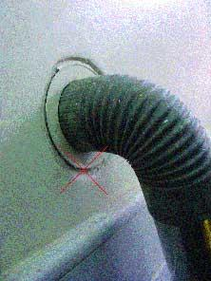

- Chimney damper bent down and lacks of proper insulation on facades of buildings, as well as putting the chimney in the water can cause choking.
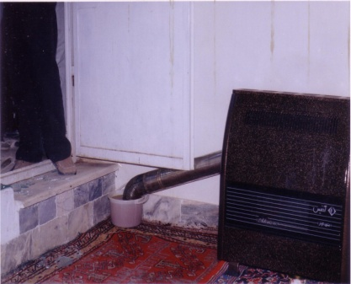
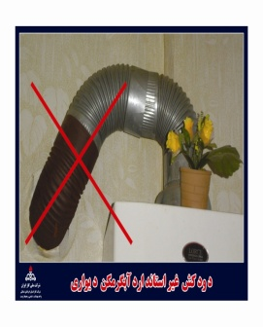
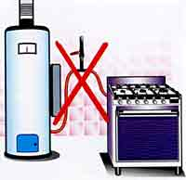

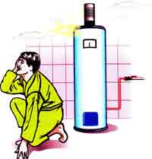
- Installing of water heater or gas heating device in the bathroom is the second important choking factor between the natural gas users.
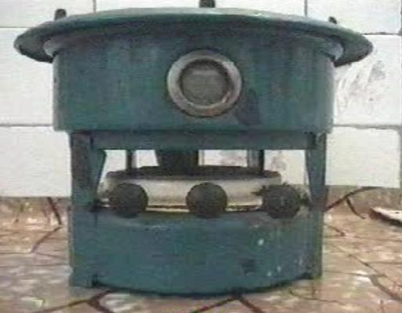

- Using equipment other than standard heater, such as single flame gas stove (cooker) or converted heater as a heating device, is the other important choking factor

- Using improper heating devices and misuse of standard heating devices (such as not using inappropriate clamps, hose, illegal extension and connecting several devices to a valve) and the boiling out on the gas stove are the most important factors of fire and explosion.

